Computer stuck joined to Entra

If you machine is connected to Entra
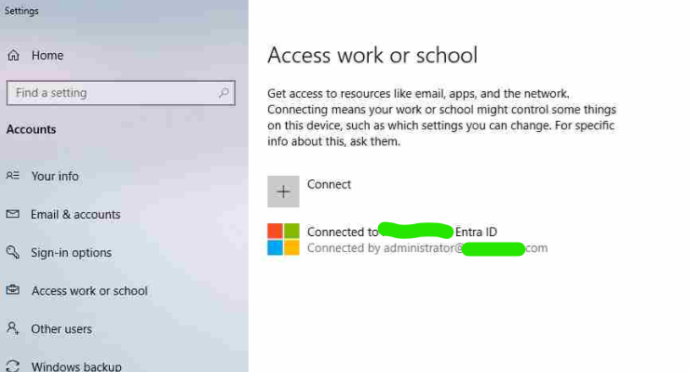
And when you try and disconnect you get something like this
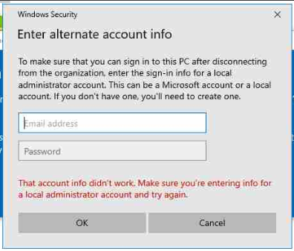
Or if you are not able to login to the computer for various reasons

Open the command prompt in Datto and run this command:
dsregcmd /status
Look through the output for this:
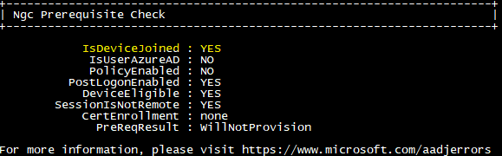
Then you can run the command
dsregcmd /leave
The command exits silently
dsregcmd /status
Will now show:
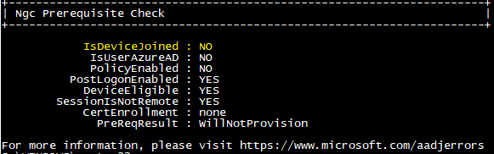

Reboot and you should no longer be azure joined

